**User manual**

1. **Login choice screen:**

* 1. **Here the user has 2 options- to register:**

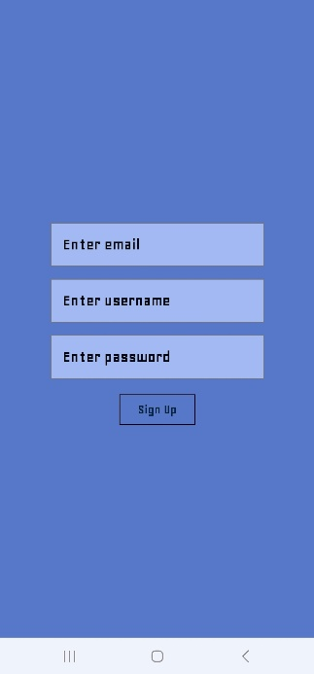

* 1. **Or to log in:**

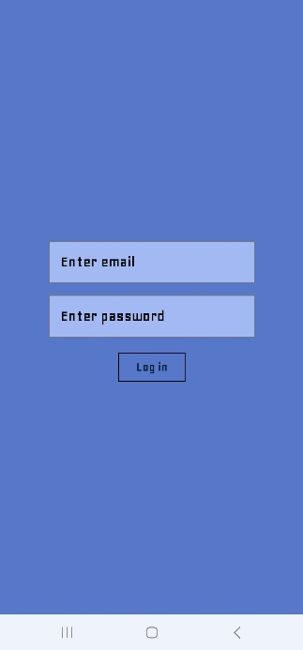

1. **Main menu screen:**

* 1. **Here the user can log out, go to settings:**

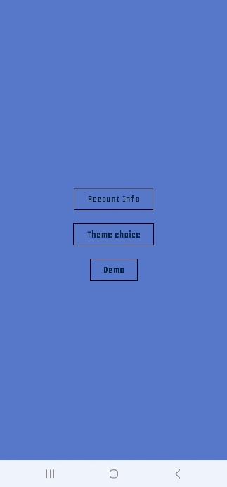

* + 1. **From settings user can go to account info screen to view their email:**

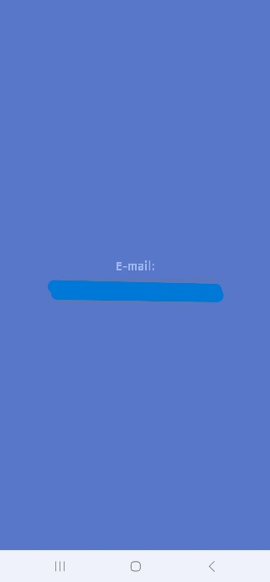

* + 1. **Theme choice screen:**

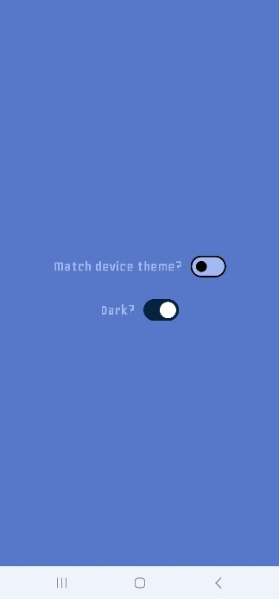

* + 1. **Demo screen (TODO)**
  1. **Play now screen:**

* + 1. **From here the user can generate a QR code:**

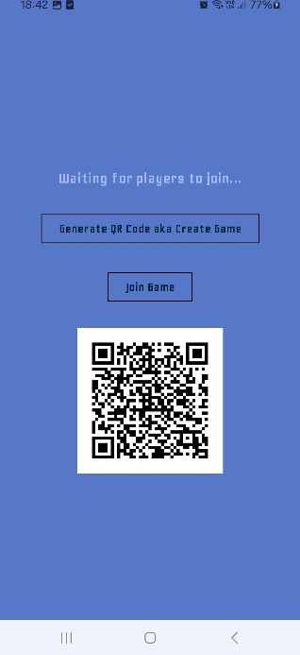

* + 1. **Or join a game by scanning a QR code**

* + 1. **After starting the game the view for both players will alternate between minigame screen:**

* + 1. **And the waiting screen:**

* 1. **Stats screen- view user’s stats**

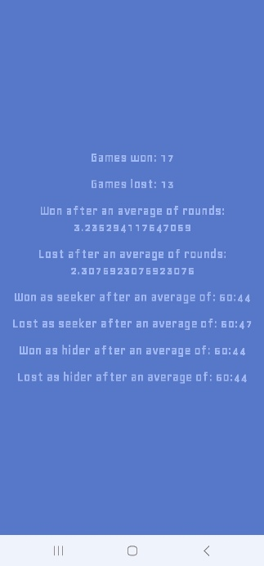

* 1. **Tutorial screen- view game rules**

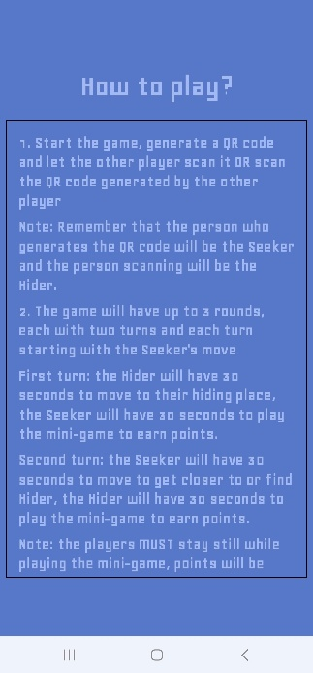

* 1. **Minigame screen- play the minigame without playing the whole game.**

